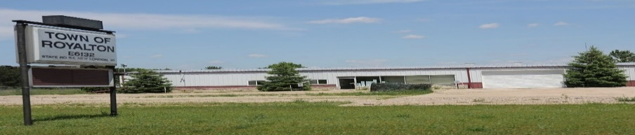
This Photo by Unknown Author is licensed under CC BY-SA
Town of Royalton
Location - E6136 State Road 54, New London, WI 54961
Chairman: Bruce Long
Clerk: Judy Doud 920-340-0085
Mailing – E6475 Heinke Rd, New London, WI 54961

APPLICATION FOR OPERATORS (BARTENDER’S) LICENSE
I hereby apply for a license to serve, from the date hereof to June 30th inclusive (unless sooner revoked). Fermented
Malt Beverages and Intoxicating Liquors, subject to the limitations imposed by § 125.32(2) & §125.68 (2) of the Wisconsin Statutes &
all acts amendatory thereof & supplementary thereto & hereby agree to comply with all laws, resolutions, ordinances & regulations,
Federal, State or Local affecting the sale of such beverages & liquors if a license is granted to me.

*PLEASE PRINT*
1. Name________________________________________________________________________________

2. Address________________________________________________________________________________

3. Phone Number_________________________________ Date of Birth______________________________

4. Name of Establishment where you will be serving alcohol________________________________________

5. Have you ever been convicted of violating law(s) of the State of Wisconsin, or the United States?
Yes________ No______
6. Have you ever been convicted of violating license law(s) or Ordinance(s) regulating sale of alcoholic
Beverages? Yes________ No______
7. If you answered YES to questions 5 or 6, complete the questions below.
Date of Conviction: __________________________________________________
Outcome: __________________________________________________________
8. Were you issued an Operator’s License from the Town last year? Yes_____ No____
9. Have you completed an approved Responsible Beverage Server Training Course as required by §125.17(6)?
Yes_____ No _____
*If you did not have a bartender license with Town previously, attach copy of training certificate*
APPLICANTS STATEMENT
I hereby certify that the answers on above application are complete, true and correct. I understand The Town of Royalton will perform a backround check. I understand omissions or falsifications are grounds
for denial of license application, or revocation of any issued license.
I agree that by granting this license, I will comply with laws of the State of Wisconsin & the Town ordinances.

______________________________________________________
Signature of Applicant Date

